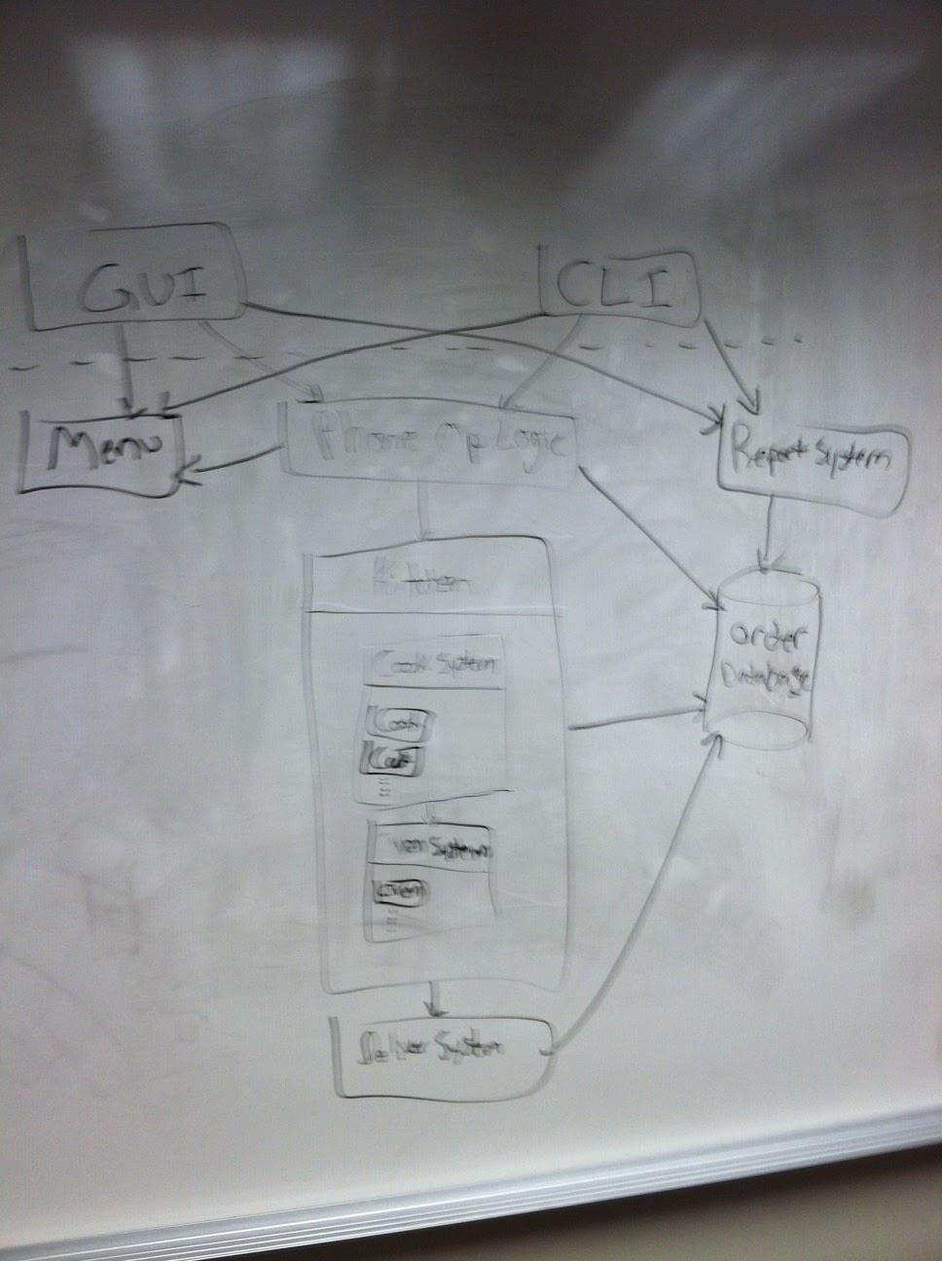

Note for this next pic, stageTimes is part of OrderItem. Almost everything in this diagram has been coded, so it’s probably best to refer to the code instead.

